Appendix B

MODELING TOOLS

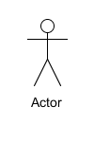The Use Case Diagram

An actor can represent the involvement of the user in the system. It will be carried when the user interacts in the system.

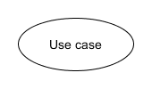

It is typically defining the interactions between a role (known in the Unified Modeling Language (UML) as a "actor") and a system to accomplish a goal.

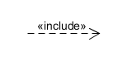

The inclusion statement is used to add new steps to the use case's sequence.

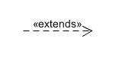

The extend relationship was used to define the behavior of an optional behavior in a use case.

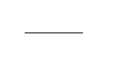

The association was used as a line communication between user and the hardware or software of the system.

Association

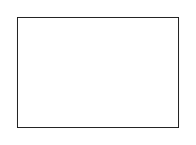

This represents the boundaries and limitations of the system.

Class Model

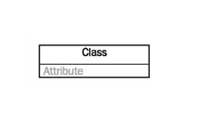

A class represents a relevant concept from the domain, a set of persons, objects, or ideas that are depicted in the IT system.

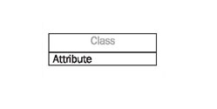

An attribute of a class represents a characteristic of a class that is of interest for the user of the IT system.

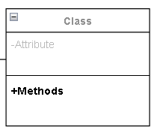

The methods are represented in the form of a list, where each method is written in a single line. It demonstrates how a class interacts with data.

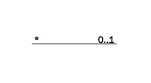

A multiplicity allows for statements about the number of objects that are involved in an association.

Database Schema

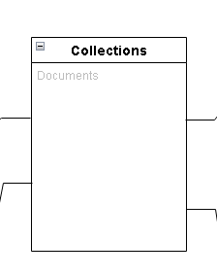

Collection is similar to tables in relational database, they store data but in the form of documents. simply a grouping of documents that have the same or a similar purpose.

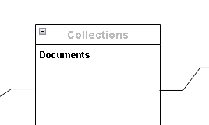

Document on NoSQL database which stores data as JSON documents instead of columns and rows.

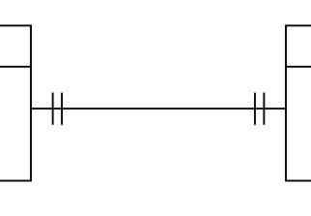

One-to-one. In a one-to-one relationship, one document in a collection is associated with one and only one document in another collection.

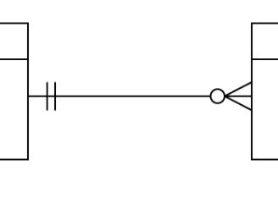

One-to-many. In a one-to-many relationship, one document in a collection is associated with many documents in another collection.